

JOURNAL OF APPLIED ARTIFICIAL INTELLIGENCE RESEARCH
ISSN 9876-1234
https://jaair.utm.my/index.php/jaair

How to cite this article:
Katuk, N., Brown, P., & Yusof, Y. (202X). The title of your manuscript: Read and follow this guideline to avoid desk rejection. Journal of Applied Artificial Intelligence Research, XX(X), XX-XXX. https://doi.org/10.32890/JAAIR202X.XX.X.X

The Title of Your Manuscript: Read and Follow This Guideline
^{1*}First Author, ²Second Author & ³Third Author
^{1&3}Faculty of Artificial Intelligence, Universiti Teknologi Malaysia, Malaysia
²School of Data, Science and Engineering, Sorbonne University Abu Dhabi

^{*1}iroslina@utm.my
²hamad_elias@gmail.my
³azri@utm.my
*Corresponding author

Received: 5/5/2025 Revised: 26/6/2025 Accepted: 5/7/2025 Published: 31/7/2025
ABSTRACT
This template should be used by authors submitting papers to the Journal of Applied Artificial Intelligence (JAAIR). JAAIR is a newly established journal published by UTM Press. Before submitting a manuscript to JAAIR, authors should carefully read the instructions in the template and use this file to prepare the manuscript before submission. Please note that the manuscript must be written in UK English. The Abstract should contain about 250 to 300 words with no more than five keywords. It is usually one paragraph long and should succinctly summarise the background of the study, the problem that the study intends to address, and the objective of the study. It also contains the methodology, the results, and the author’s interpretation and implications of the results and conclusions. Avoid citing references in the Abstract.

Keywords: List a maximum of five keywords in alphabetical order and separated by commas.

INTRODUCTION

To begin formatting your manuscript, please save a copy of the JAAIR template file as a new document. Then, copy and paste the content of your manuscript from your working draft into this new file. This ensures that all formatting—such as margins, font styles, paragraph spacing, headings, and styles—follows the official JAAIR requirements. Avoid modifying the template structure or styles, as doing so may result in formatting inconsistencies that could delay the review or publication process.

The Introduction section should present a clear and focused background of the study. Begin by explaining the topic and its relevance in a broader context. Then, describe the specific problems or challenges that the study intends to address. Use straightforward language to ensure the content is accessible and easy to follow.

related works

2.1 Length of Manuscript

Authors must prepare their manuscript using Microsoft Word and format it according to the official JAAIR template as in this file. The word count requirement varies depending on the type of article submitted. For original research papers, the manuscript should span between 5,000 and 8,000 words, while review articles may range from 8,000 to 10,000 words, including all sections such as the Abstract, main text, tables, figures, and references.

For another subsections, author shall use the bullet points based on alphabet as follows:
- Content one.
- Content two.

2.2 Format for Table

All tables should follow the journal’s formatting standards. Use Times New Roman, 10-point font size for both the table content and headers. Table titles must appear above the table, written in italicised title case, and left-justified. The table number must be boldfaced and left justified. Keep the table layout clean by avoiding vertical lines, and use horizontal lines only at the top, bottom, and immediately below the header row. All text within the table should be consistently aligned—either centred or left-justified, depending on the content. Authors must ensure that each table is explicitly referenced in the main body of the text (e.g., “as shown in Table 1”) to aid reader navigation. By following these guidelines, authors can use tables not only as a visual aid but also as a powerful tool to justify the novelty and significance of their work in comparison to existing studies.

Table 1: Sample of Data Collection
Data | Values | Status
172.10 | 0.08 | Very low
173.33 | 0.13 | Very low
175.88 | 0.24 | Very low

METHODOLOGY

3.1 Overview of the Proposed Framework

The Methodology section is a critical component of the manuscript and must be written in clear and detailed language to demonstrate the reliability, validity, and reproducibility of the study. This section provides the foundation upon which your results are built and should enable other researchers to replicate or build upon your work. Depending on the nature and focus of your study, this section may be titled “Methodology,” “Proposed Method,” “Proposed Technique,” or “Proposed Algorithm.” Choose the title that best reflects the scope and outcome of your research. However, regardless of the title used, the content must thoroughly explain the steps, processes, tools, datasets, or respondents involved in the study.

RESULTS and discussion

The section that presents the findings of the study can be titled according to the nature of the research. Acceptable titles include “Evaluation and Results,” “Analysis and Results,” or “Results and Discussion.” Authors should choose the most appropriate title that reflects the content and structure of their study. This section must be well-organised and clearly structured, preferably using subheadings aligned with the research questions, hypotheses, or research objectives. This will help readers follow the flow of the findings and understand how each result relates to the study’s aims. Where appropriate, use figures and tables to support and illustrate the results. All visual elements must be clearly labelled, numbered sequentially (e.g., Figure 1, Table 2), and referred to in the text. Ensure that each table or figure is accompanied by a brief yet informative caption and avoid repeating information in both the text and the table or figure.

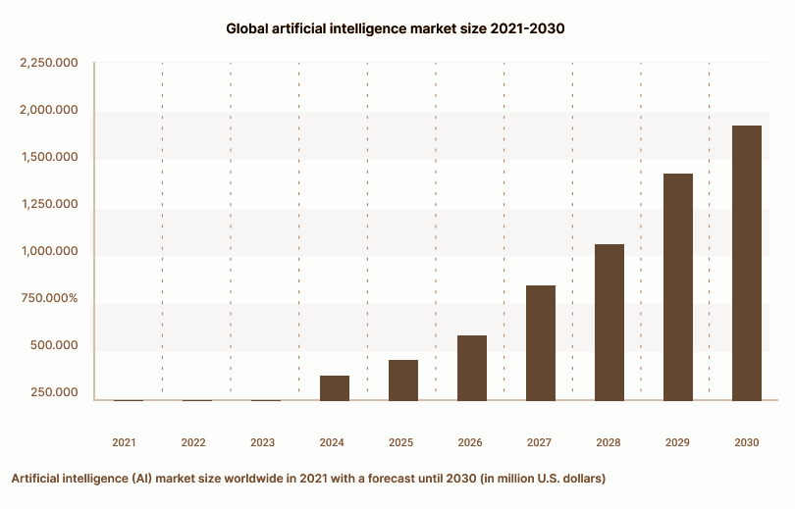
Figure 1: Comparison of Quarterly Data

4.1 Figures

All figures included in the manuscript must be clear, complete, and professionally presented, as low-quality visuals are a common reason for manuscript rejection in JAAIR. Authors should ensure that all charts, diagrams, and illustrations are fully labelled, with both X and Y axes indicated, including appropriate units of measurement. Axis labels should use a legible font size of 9–10 points, and all elements within the figure (e.g., text, symbols, arrows, legends) must remain sharp and readable at 100% zoom in Microsoft Word.

4.2 Citation and Reference Style

All manuscripts submitted to JAAIR must follow the APA 7th edition referencing style. Authors are required to ensure that all sources cited in the text are listed in the References section and vice versa. Accuracy and consistency in referencing are essential for the credibility and traceability of academic work. In-text citations should include the author’s last name and the year of publication. Depending on how the source is used in the sentence, the citation can be placed either at the end of the sentence in parentheses or incorporated into the sentence structure. Table 2 shows the examples.

Table 2: Example of Writing In-Text Citations Using APA 7th Edition
Number of authors of the reference | Citation at the end of the sentence | Citation in the sentence
1 Author | (Forouzan, 2007) | Forouzan (2007) proposed …
2 Authors | (Wegener & Petty, 1994) | Wegener and Petty (1994) suggested …
3+ Authors | (Morgan et al., 2017) | The study by Morgan et al. (2017) found …

4.3 Discussions

At the end of the Results section, authors must include a concise Discussion that answers the essential “So what?” question. Interpret the findings rather than repeating numbers. Explain what the results mean, why they matter, and how they address the research questions, hypotheses, or objectives stated earlier. Situate the outcomes within the literature by comparing with related studies (cite appropriately), noting consistencies, divergences, and plausible reasons (e.g., data, context, assumptions). Highlight the implications: theoretical contributions (e.g., how the work advances concepts or models), practical or policy relevance, and potential impacts on systems, tools, or stakeholders.

CONCLUSION

The Conclusion section should be written clearly and purposefully, focusing on the implications of the results rather than repeating content from the Abstract or earlier sections. Authors should not summarise the entire study, as this has already been addressed in the Abstract. Instead, this section should explain the significance of the findings, highlighting how the results contribute to solving the problem introduced in the study. It is important to address the limitations of the results, such as constraints related to data generalisability, model sensitivity, or applicability under specific conditions. The author can discuss the limitations of the study design, Methodology, or sample in this section. The emphasis should remain on interpreting what the results mean and how they may inform future work.

ACKNOWLEDGEMENT

Any acknowledgements by the author may appear here. Acknowledgements of people, grants, and funds should be brief and concise.
REFERENCES

Abbasi, Q., Lew, P., Rafique, I., & Li, Z. (2012). User experience evolution lifecycle framework. International Journal of Social and Human Sciences, 6, 39-44.
Abdellatif, A. J., McCollum, B., & McMullan, P. (2018). Serious games: Quality characteristics evaluation framework and case study. Paper presented at the 2018 IEEE Integrated STEM Education Conference (ISEC).
Abeele, V. V., Spiel, K., Nacke, L., Johnson, D., & Gerling, K. (2020). Development and validation of the player experience inventory: A scale to measure player experiences at the level of functional and psychosocial consequences. International Journal of Human-Computer Studies, 135, 102370.

